Early Stroke Detection Using ML Classifiers:
AA1-501 Final Project

Alvaro Folgueira
University of San Diego
Summer 2026 B AAI-501
Professor Andrew Van Benschoten

Abstract
Strokes today make up the leading cause of mortality and long-term disability around the world (Feigin et al., 2025). It is important to identify cases early in order to prevent patient death and/or irreversible neurological damage. Traditional methods of assessing risk make use of linear scoring systems, which are generally too inflexible and therefore fail to take into account the complex, non-linear interactions in patients such as demographic factors, lifestyle, and physiological characteristics, among others (Chun et al., 2021). In order to overcome this drawback, the aim of the project has been to discover the most suitable data-driven approach by means of a predictive pipeline that identifies high-risk individuals through a combination of linear and tree-based machine learning models, with the objective of determining which model performs best. Since the medical consequences of failing to detect potential stroke patients are so serious, the pipeline is designed to prioritize reducing false negatives, even if this means increasing false positives, by focusing on a high level of Recall together with overall Model Discrimination (ROC-AUC). After the initial evaluation of the base models, the most effective ones were chosen and their hyperparameters were tuned using 5-fold cross-validation. The final, optimized model obtained a validation ROC-AUC of 0.83 and a Recall of 0.80 on the independent test set, showing that it has good potential as a clinical decision-support tool for early intervention.

Table of Contents
Abstract 2
Table of Contents 3
Project Context and Goals 5
Pipeline Overview 5
Figure 1 6
Data and EDA 7
Data 7
Data Split 7
Figure 2 8
EDA 8
Tabular data summary 8
Data Types 9
Figure 3 10
Missing Values 11
Summary Statistics 11
Figure 4 12
Class Imbalance 12
Figure 5 13
Outliers Analysis 13
Figure 6 13
Univariate Visualization 14
Figure 7 15
Figure 8 15
Bivariate Visualization 16
Figure 9 17
Figure 10 18
Multivariate Visualization 18
Figure 11 19
Figure 12 20
Figure 13 21
Pre-Processing and Feature Engineering 22
Figure 14 23
Data Pre-Processing 24
Missing Value Imputation 24
Figure 15 25
Data Cleansing & String Normalization 25
Figure 16 27
Target Class Oversampling 28
Figure 17 29
Feature Engineering 29
Categorical Feature Encoding 30
Figure 18 31
Logarithmic Transformation 31
Robust Feature Scaling 32
Figure 19 32
Base Model Training and Tuning 33
Base Models 33
Figure 20 34
Figure 21 35
Linear Models 36
Figure 22 37
Tree Models 37
Figure 23 38
Base Model Selection 38
Tuning 39
Figure 24 40
Figure 25 41
Hyperparameter Tuning 42
Figure 26 42
Threshold Tuning 42
Figure 27 43
Model Results and Final Model Selection 43
Figure 28 44
Final Test 44
Figure 29 46
Deployment Impact and Implications 47
References 48
Declaration of AI Use 48

Project Context and Goals
The project aims to build an automated machine learning predictive tool that will assist in the early detection of potential stroke victims before an event occurs. That being said, the objective of this tool is not to provide a formal medical assessment or prescribe treatment, but simply to provide an early indication or alert recommending immediate medical attention.
For this reason, the intended direction of development is to have the models lean toward a more conservative predictive pattern, where as many true positive cases are identified as possible, even at the expense of potentially more false positives. Nevertheless, achieving a critical balance between high sensitivity and operational feasibility remains essential.

Pipeline Overview
The project is structured as a centralized, reproducible, and maintainable architecture. It is composed of a series of modular, object oriented jupyter notebooks executed through a central master notebook (pipeline.ipynb). The object oriented approach allows for an iterative and customizable parameter parsing approach for every element in the pipeline.

The pipeline ingests raw clinical and demographic patient data, performing standardized data cleaning, feature encoding, scaling, and class-imbalance adjustments before routing features to model execution. The evaluation process follows a top performance picking process, where models are initially picked from a list of trained models, and then tuned in which the top performing model is finally picked. The complete end-to-end architecture and sequential data flow are illustrated in Figure 1..

Figure 1
Iterative Machine Learning Pipeline for Predictive Modeling and Evaluation
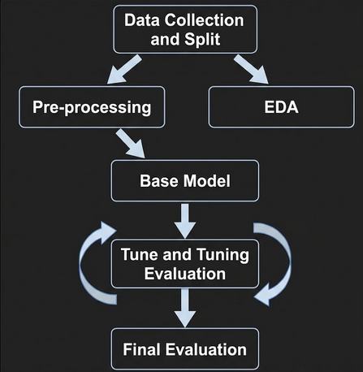

Note: Tuning and Tuning Evaluation Process is iterated multiple times if necessary to arrive at the required parameter and its tuning.

Data and EDA

Data
The study analyzes a dataset, imported from Kaggle, which contains the clinical and demographic records of 5,110 individual patients and was gathered in order to assess the risk factors linked to acute cerebrovascular events. This dataset consists of 10 predictor variables together with a binary target variable (stroke), and it covers the patients' demographic features (age, gender, marital status, work type, residence type), their clinical measurements (hypertension, heart disease, average blood glucose level, body mass index [BMI]), and their lifestyle habits.

Data Split
The dataset is split using 70-15-15 partitions (Figure 2). There is a 70% training partition that will be used exclusively for training the model, and a 15% validation partition that will be used to judge the model’s performance given specific tuned parameters and preprocessing actions. These two partitions are free to be iterated on multiple times throughout the development process in order to achieve the best performance for the models. Finally, the 15% test partition will be used exclusively for testing the final picked model, and this testing partition should remain completely sealed until final testing.

Figure 2
Data/Feature Classification Table
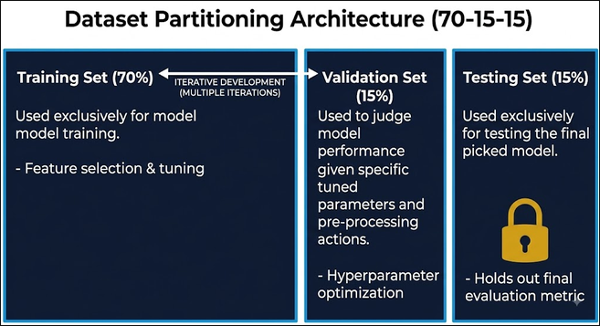
Note. Dataset split architecture (70% training, 15% validation, and 15% testing), where training and validation partitions are used iteratively during development, while the testing partition remains completely sealed and untouched until final model evaluation.

EDA
The exploratory data analysis is separated into 4 sections designed to reveal patterns for future processing. It consists of tabular data summary, univariate visualization, bivariate visualization, and multivariate visualization.

Tabular data summary
In the tabular data summary, an initial assessment of the dataset’s dimensions, null value proportions, data structure types, and mathematical analytics (like mean and skewness) were taken. The purpose of this procedure is to get a better understanding of how the raw data is structured and how it can be processed in order to achieve best possible results when training the models.

Data Types
Analysis reveals the dataset includes five categorical variables and six numerical variables. Of the categorical variables, three are nominal (gender, work_type, and smoking_status) and two are binary (ever_married and residence_type). With respect to the numerical variables, three are continuous (age, avg_glucose_level, and bmi) and three are represented as binary indicators (hypertension, heart_disease, and the target variable stroke), as shown in Figure 3. A visual examination of these data structures shows that categorical encoding should be carried out before estimating the model.

Figure 3
Data/Feature Classification Table
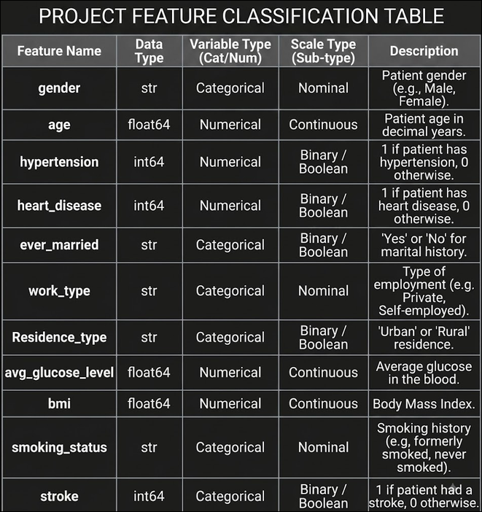

Note: Classification of dataset features by data types, variable type, scale type, and its description.

Missing Values
In terms of null/missing entries, the data set is fairly clean. Only one feature contains missing rows: bmi containing 148 null rows, roughly 2.9% of the dataset. Because the missingness accounts for less than 5% of the observations, it is assumed to be Missing Completely at Random. To prevent bias and preserve the data set as best as possible, these missing entries are later addressed.

Summary Statistics
Exploratory analysis of the data highlights clear patterns in the way the values are distributed and spread out (Figure 4). The ages in the sample are fairly evenly distributed, covering the range from infants (0.08 years) to the elderly (82 years), the mean age being 43 and the distribution showing only a slight skew. In contrast, both avg_glucose_level and bmi display obvious right skewness and include some extremely high values—such as a maximum BMI of 92.0 and a glucose level of 271.74. The presence of these skewness demonstrates a clear need for feature scaling or transformation before training the model.
In terms of the binary features, mean and skewness values indicate heavy feature imbalance, where the majority of subjects demonstrated a lack of hypertension and heart_disease (roughly 9.6% showing hypertension and 5.4% showing heart disease). To prevent underestimation of the features predictive impact, this skewness must be addressed.

Figure 4
Summary Statistics Table
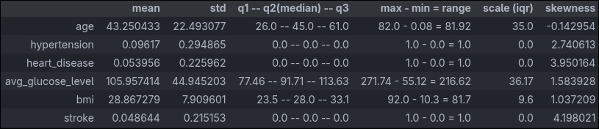
Note: Descriptive statistics for numerical and binary dataset features. The following statistics are shown: central tendency (mean, median), dispersion (std, range, IQR), and skewness.

Class Imbalance
One important detail that can be seen in Figure 4 summary statistics is the presence of heavy class imbalance. The target variable’s imbalance is so severe that only 4.86% of subjects indicate history of stroke (as seen in Figure 5). If not addressed, models will show very high bias toward the majority class which will result in misleading, inflated performance and accuracy metrics while failing to identify true stroke risk. The handling of this imbalance is discussed in later sections.

Figure 5
Target/Class Feature Summary
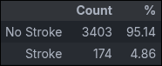
Note. Class distribution of the target variable (stroke), illustrating severe imbalance with only 4.86% (174 cases) representing positive stroke history.

Outliers Analysis
A closer look at the outlier statistical summary reveals significant outliers across continuous features, with avg_glucose_level reaching an outlier percentage as high as 12.19% (436 instances) and bmi at 2.21% (79 instances) as seen on Figure 6. If not addressed, these extreme values could distort model training (especially linear models) and lead to inaccurate predictions.

Figure 6
Continuous Outlier Summary
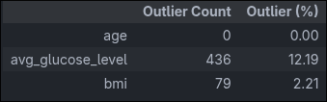
Note. Summary of continuous feature outliers identified using the 1.5 x IQR rule.

Univariate Visualization
Univariate analysis reveals key distribution patterns and structural imbalances present among both the numerical and categorical variables in the dataset. The numerical continuous variables have clear distribution shapes: age has a fairly wide, uniform to bimodal distribution covering the range from infants up to over 80 years of age, BMI shows a slightly right-skewed normal distribution centered near 28, and avg_glucose_level has a marked right skew with a long upper tail that goes beyond 250 mg/dL (Figure 7). When the binary features are visualized, the severe class imbalance is once again confirmed, since the number of positive cases represents only a small part of the total cases (Figure 8). With respect to the categorical attributes, gender is mainly female, ever_married is mostly "Yes", and work_type is largely made up of people in the "Private" sector, while Residence_type is almost equally divided between urban and rural residents. Moreover, smoking_status includes a large number of "never smoked" and "Unknown" entries.

Figure 7
Univariate numerical feature distributions (histograms with KDE curves)
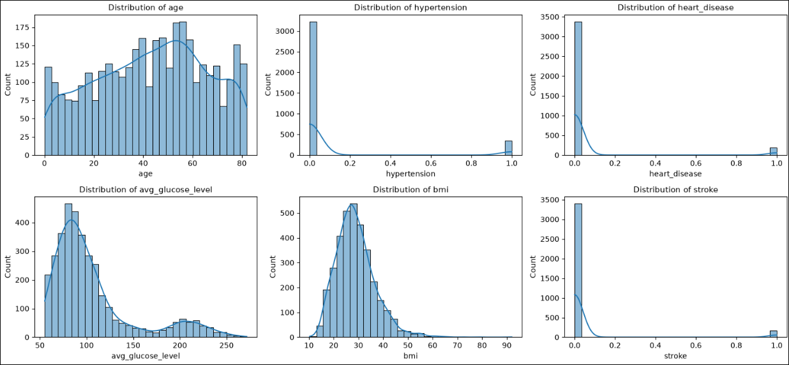
Note. Histograms showing right-skewed glucose levels and BMI alongside severe imbalance in binary health conditions and the target variable.

Figure 8
Univariate categorical feature value counts (frequency bar plots)
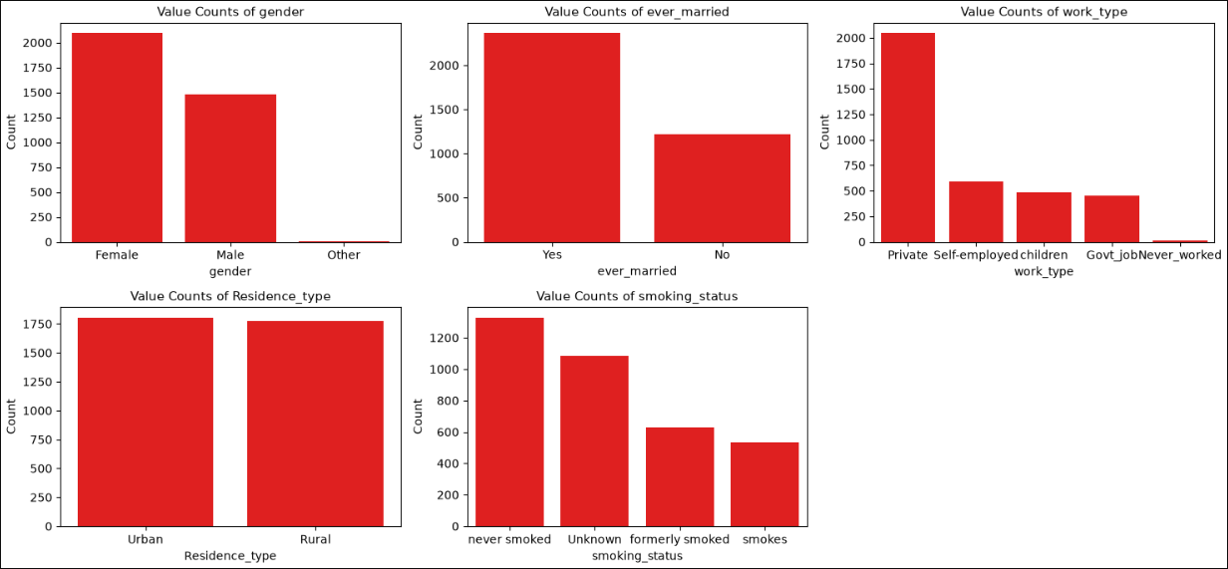
Note. Bar charts illustrating categorical class balances, dominated by private-sector employment, married status, and female representation, with balanced urban/rural residency.

Bivariate Visualization
A bivariate analysis shows the relationships between the predictor variables and the target variable as well as the degree of collinearity among the features. The correlation matrix (Figure 9) shows that age has the strongest linear and monotonic relationship with stroke occurrence (with a Pearson correlation of about 0.25). The other numerical and binary variables, including heart disease, average glucose level, and hypertension, show positive but much weaker correlations with the target variable (ranging from 0.12 to 0.14). Looking at the actual stroke rates (Figure 10) within the different distributions of the features, the major effect of age is very clear in that the stroke rate increases exponentially as age goes up and reaches a sharp peak in the oldest age groups (64 to 74+ years). In a similar way, average glucose level shows a clear pattern with the stroke rate rising significantly among those in the highest glucose groups (above 123 mg/dL). BMI, on the other hand, shows a peaked trend: the stroke rate increases steadily until it reaches the overweight to mildly obese range (a BMI of about 30 to 32) and then slightly decreases in the highest BMI categories.

Figure 9
Bivariate numerical feature correlations (Pearson and Spearman)
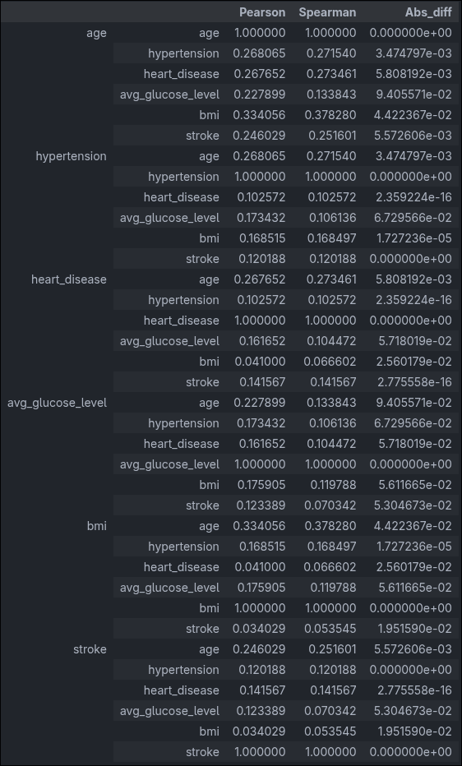
Note. Correlation table highlighting that age has the strongest positive correlation with stroke among all numerical features, while overall collinearity between predictors remains relatively low.

Figure 10
Stroke rate across numerical feature bins (line plots)
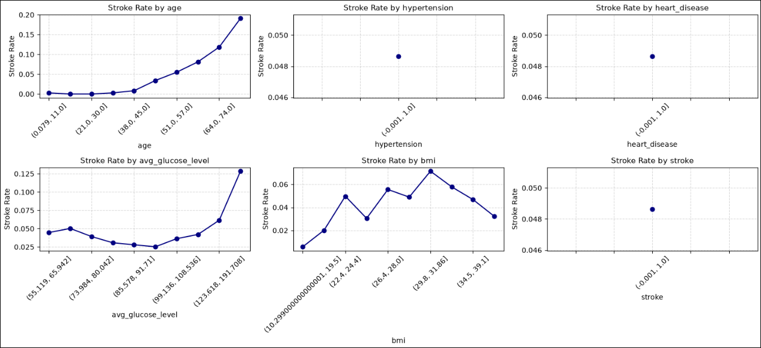
Note. Line charts demonstrating a sharp, exponential increase in stroke incidence with advancing age and elevated average glucose levels, alongside a non-linear, peaked trend for BMI.

Multivariate Visualization
Multivariate analysis gives a thorough insight into the way various features interact across different data types, identifying collinear relationships that might affect model performance. The correlation matrix covering all six numerical and binary features (Figure 11) confirms that collinearity is generally low, the most prominent relationships being between age and BMI (0.33) and age and hypertension (0.27). When the categorical variables are examined using Cramér’s V (Figure 12), a strong association is found between ever_married and work_type (0.57), showing a significant overlap in the groups that these variables refer to. The Correlation Ratio matrix (Figure 13), which links numerical and categorical features, shows strong connections mainly due to age. It is not surprising that a patient's age has a major influence on both their marital status (0.68) and their work type (0.69). BMI also shows moderate associations with work_type (0.49) and ever_married (0.40). These results show that although there is little direct multicollinearity among the predictors, age functions as a basic demographic factor closely linked to several lifestyle factors.

Figure 11
Correlation Matrix of Numerical and Binary Features
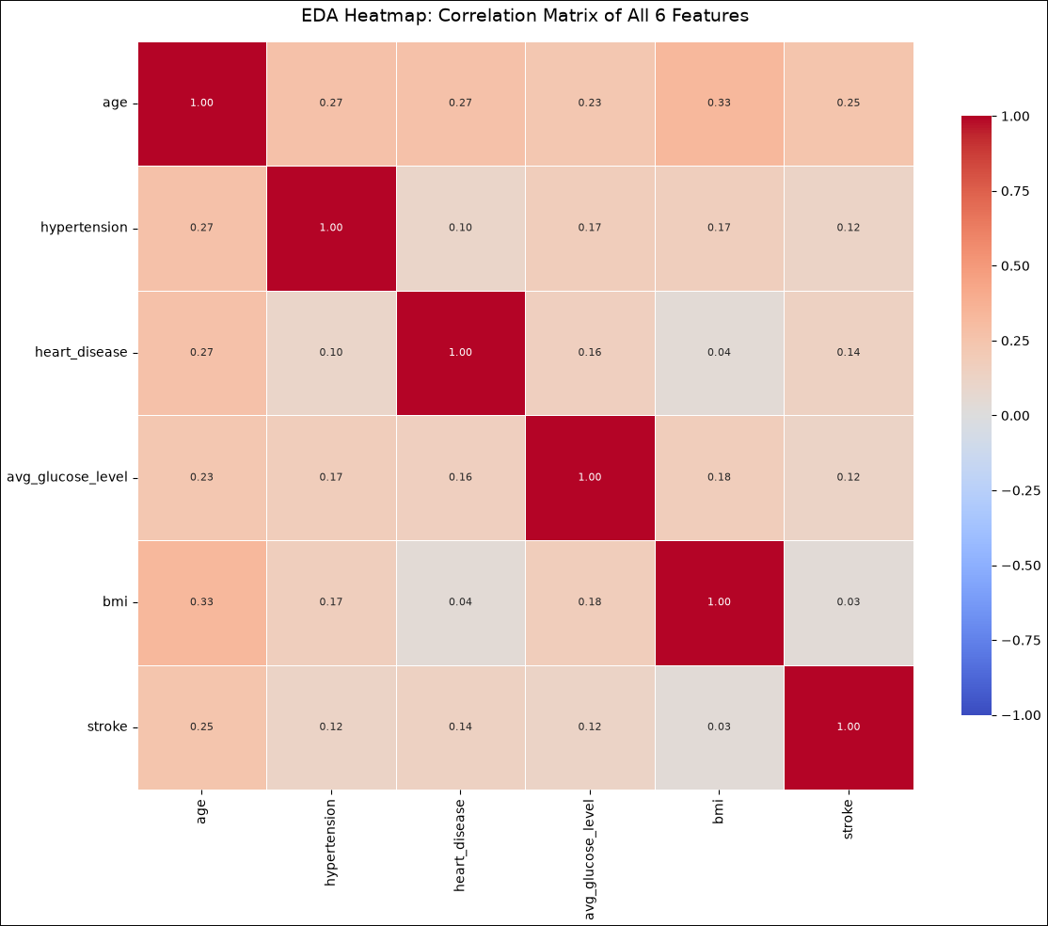
Note. Heatmap detailing the lack of severe multicollinearity among the six numerical and binary features, with the strongest relationships appearing between age and BMI, and age and hypertension.

Figure 12
Cramér's V Association Matrix of Categorical Features
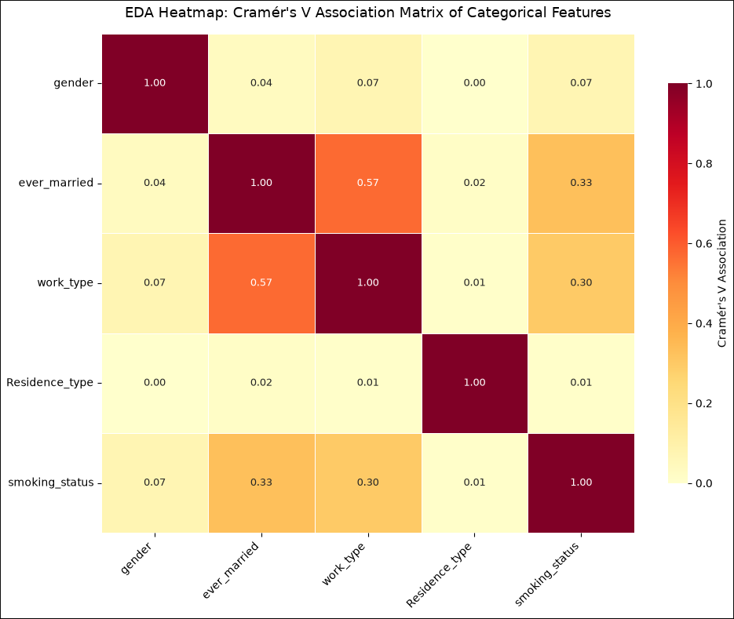
Note. Heatmap displaying the associations strictly between categorical variables, highlighting a strong relationship between marital status (ever_married) and work_type.

Figure 13
Correlation Ratio Matrix (Numerical vs. Categorical Features)
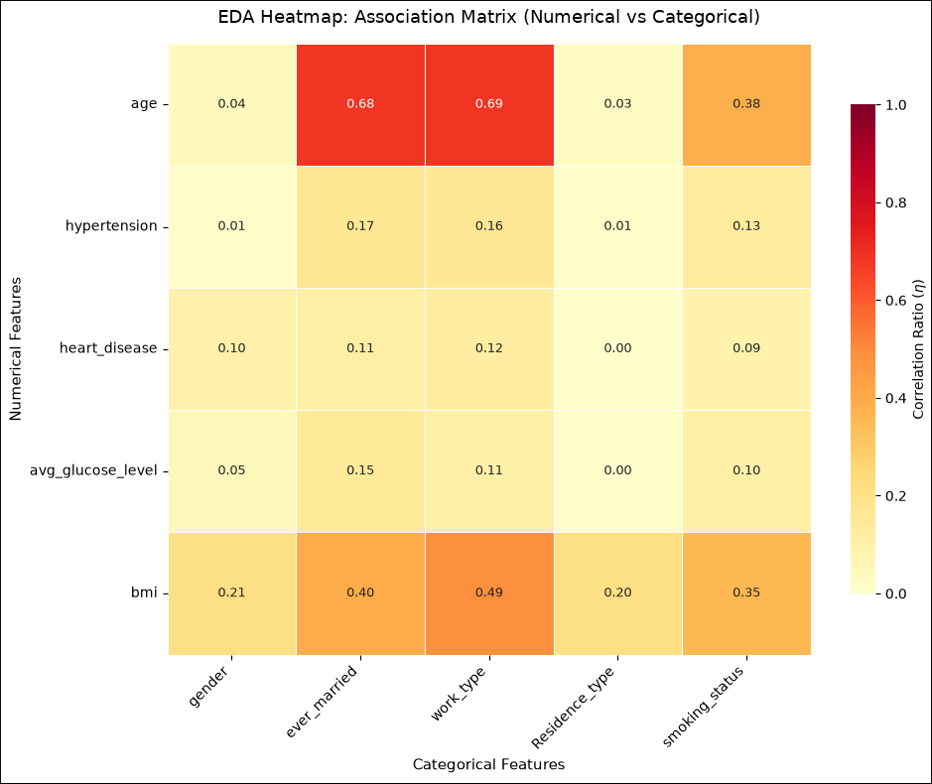
Note. Heatmap illustrating the strong expected associations between the demographic anchor of age and lifestyle categories such as work type and marital status.

Pre-Processing and Feature Engineering
Raw datasets are rarely ready for ML development from the start. As discovered during the EDA section, the dataset contained noise, missing values, structural inconsistencies, and scale disparities that can compromise model performance. By applying pre-processing and feature engineering steps, the algorithm can bridge the gap between messy observational data and robust predictive models.

The various data preparation steps are all carried out within a Pre_Processor class (notebook 03_pre_process.ipynb) in order to ensure that the pipeline remains modular and to prevent data leakage. This class uses the fit() method to calculate the statistical parameters (for example, medians, scaling factors and category mappings) solely on the training data, the transform() method to apply these learned rules consistently to different datasets, and the fit_transform() method to manage the execution of the pipeline together with rebalancing of the target class (Figure 14).

Figure 14
Pre_Processor Fitting, Transformation, and Resampling Execution Algorithm
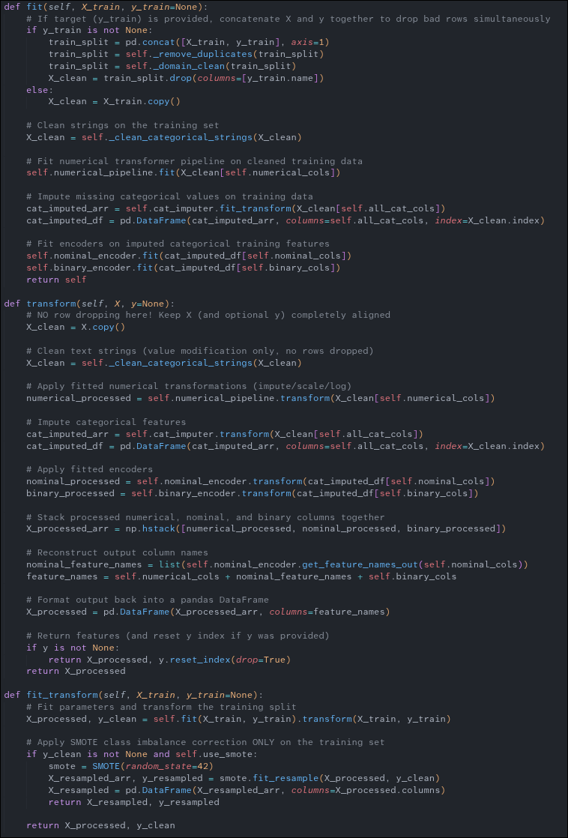
Note. Core Pre_Processor execution methods (fit, transform, and fit_transform) implementation. By setting the default value parameter “y = None”, flexible use of the pipeline is enabled in cases where predicting labels for previously unseen test data is required, allowing for more modularity and reproducibility. The class limits row-pruning operations to the fit() method and carries out SMOTE oversampling only within the fit_transform() method when training, in order to avoid data leakage and index misalignment.

Data Pre-Processing
Pre-processing will entail handling of the initial cleansing, structural conversion, and class rebalancing of the raw dataset into a mathematical sound format accessible by the models.

Missing Value Imputation
From the EDA section, 2.9% of the data (more specifically from the bmi feature) is missing. A SimpleImputer using a median strategy was applied to numerical columns (Figure 15), substituting missing entries with feature medians to prevent distributional distortion while preserving dataset completeness without introducing observational bias (as opposed to listwise deletion, which would discard valuable observations and reduce sample size).

Figure 15
Feature Imputation Code
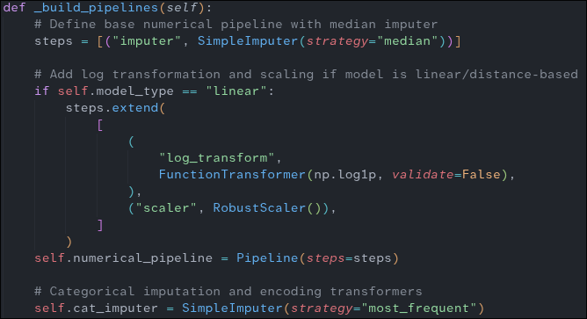
Note. The _build_pipelines method is an internal helper function initialized alongside the object instance. Within it, several preprocessing steps are configured, including missing value imputation. For numerical features, a SimpleImputer using a median strategy is added to the pipeline steps. Although there are no missing categorical values in the raw dataset, a categorical imputer (which fills empty entries with the most frequent value) is included for the sake of modularity and repeatability.

Data Cleansing & String Normalization
In order to ensure strict data integrity prior to carrying out statistical modelling, the raw text entries and the domain-specific edge cases must be standardized. Categorical strings generally have formatting noise, trailing whitespace, or implicit indicators of missing data (for example, "Unknown", "NAN", "NaN", or empty strings ""). The pipeline includes a step which carries out string cleaning by removing any whitespace and then explicitly converting these ambiguous strings into true np.nan values so that they can be dealt with consistently further down the line.

In addition, domain-specific validation rules are applied using _domain_clean to eliminate records that are not plausible—this involves checking that the age is within a valid range (between 0 and 120), that the body mass index is positive (BMI greater than 0), and that the gender is correctly classified. Exact duplicate rows are likewise removed for each feature-target pair using _remove_duplicates. In order to avoid data leakage and to prevent row alignment problems when testing, these row-dropping cleansing steps are carried out strictly during the fit() phase with the training data. The pipeline code can be seen in Figure 16.

Figure 16
Feature Imputation Code.
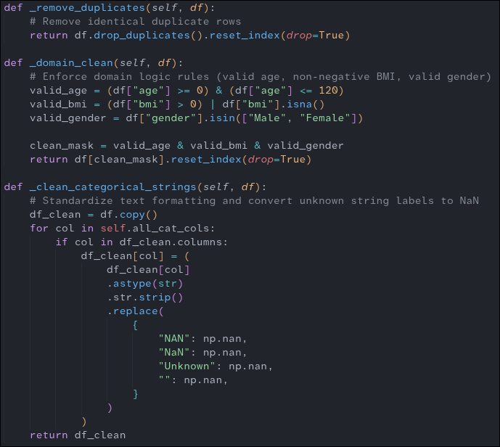
Note. The _clean_categorical_strings method alters the values of features without changing the number of rows, making it safe to use both in fit() and in transform(). On the other hand, _domain_clean and _remove_duplicates eliminate whole rows. If these are placed only within fit(), then bad records are removed during the training process without causing a misalignment between the rows of X and y when testing.

Target Class Oversampling
In order to amend the severe class imbalance in the target variable (stroke encompassing only about 4.86% positive cases of the observations), the Synthetic Minority Over-sampling Technique (SMOTE) was included in the training phase (Chawla et al., 2002). This method avoids majority-class bias and prevents the inflation of the performance metrics by creating a synthetic number of instances for the minority class solely on the training subset, without causing data leakage. SMOTE functions in the feature space by picking a data point from the minority class and then finding its nearest minority neighbors with the help of Euclidean distance; it then selects one of those neighbors at random, draws a line segment between the two points in the feature space, and creates a new synthetic data point at a randomly chosen location on that line segment. A visual of the process is shown on Figure 17. The SMOTE transform is run through the fit_transform function of the code, Figure 14.

Figure 17
Synthetic Minority Over-sampling Technique (SMOTE) Workflow.
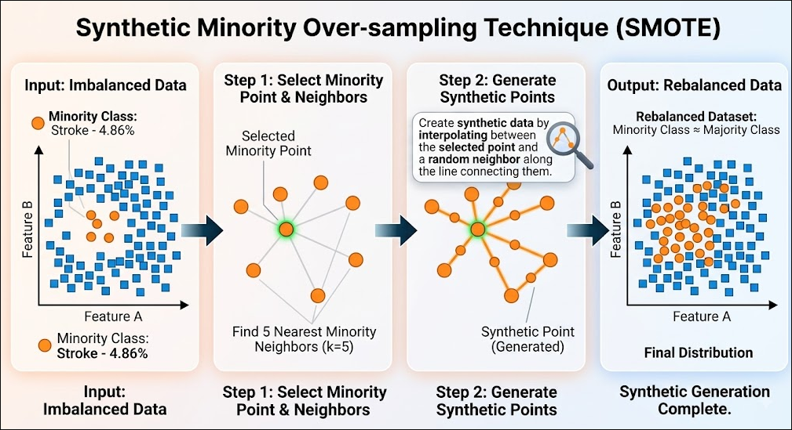
Note. Conceptual workflow of SMOTE for handling class imbalance (4.86% minority class). It generates synthetic points by interpolating between minority samples and their k-nearest neighbors. Executed strictly within fit_transform() on training data, it rebalances class proportions while preventing data leakage.

Feature Engineering
With dataset cleaning completed, the next step is to prepare the features for model-ready application. To secure stable and reliable performance, features are engineered into appropriate mathematical structures. Continuous features are scaled to prevent high-magnitude metrics from dominating predictive outcomes across different variables. Furthermore, to address feature skewness and linearize non-linear relationships, logarithmic transformations are applied alongside structural categorical encodings.

Categorical Feature Encoding
Categorical features are engineered into mathematical structures. The variables are transformed into explicit numeric representations based on their scale type. For instance, non-ordinal nominal features are encoded into binary indicators columns – for example the feature work_type is engineered to work_type_Private (0 or 1), work_type_Self-employed (0 or 1), work_type_Govt_job (0 or 1), etc. – using OneHotEncoder. Binary features are also encoded, mapped to 0 or 1 numeric values using OrdinalEncoder. Overall, a total of 12 new encoded features were created (Figure 18). In terms of the pipeline, the encoders are initialized first in the object, then passed to a fit function where the encoders learn the categorical features, then the transformations are applied from the transform function (Figure 14).

Figure 18
Engineered Feature Encoding Summary.
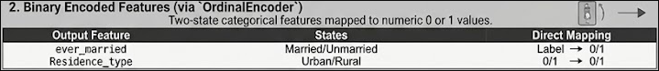
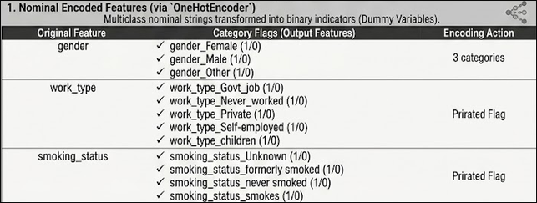

Note. Summary of the feature encoding pipeline, expanding 5 raw features into 14 model-ready features via nominal one-hot encoding.

Logarithmic Transformation
To address feature skewness and non-linear relationships, continuous numerical features are engineered using logarithmic transformations. Continuous attributes (age, avg_glucose_level, and bmi) undergo a log(1+x) mapping via FunctionTransformer (np.log1p) to compress extreme upper-tail distributions—such as highly skewed glucose values—and linearize continuous relationships for downstream models. Overall, a total of 3 continuous features were transformed using this approach. In terms of the pipeline, the FunctionTransformer is integrated directly within the numerical pipeline in the object's init, fitted to the data structure alongside the simple imputer during fit(), and then executed to map the skewed feature distributions into compressed scales within the transform() function (Figure 14).

Robust Feature Scaling
Continuous numerical features are transformed into standardized mathematical structures to ensure balanced feature weightings across models. Continuous attributes (age, avg_glucose_level, and bmi) are scaled using RobustScaler in order to guard downstream algorithms against extreme outliers—for example, glucose levels as high as 271.74.Different from variance-based scalers such as StandardScaler, RobustScaler uses median and Interquartile Range (IQR) statistics to scale the features, thus retaining the central part of the distribution without being distorted by the presence of long-tailed extreme values. Overall, a total of 3 continuous features were transformed as part of this process.With regard to the pipeline, RobustScaler is set up inside a numerical pipeline in the object's init method, is learned together with the imputation and log transformations during the fit() phase, and is then used to normalize the numerical feature array in the transform() function (Figure 14).

Overall, the pre-processing pipeline for numerical features is composed as follows (Figure 19).

Figure 19
Numerical Features Processing and Engineering.
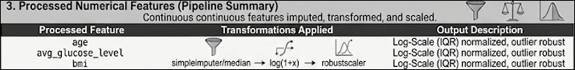
Note. Summary of the numerical pipeline

Base Model Training and Tuning

Base Models
Now that data cleaning and feature engineering are complete, the pipeline is ready to implement the base models. These base models will contain no hyperparameter tuning whatsoever at first. The workflow consists of six selected models—chosen specifically for their effectiveness on binary classification tasks—that will be trained on the preprocessed data and evaluated on the validation set. To balance model families, three linear/distance-based models and three tree-based models were selected. Based on the evaluation metrics, three of these six models will be chosen for further hyperparameter tuning, with Recall and ROC-AUC serving as the primary decision metrics to prioritize stroke detection sensitivity and threshold-independent performance. It must be reiterated that throughout this process, the test set partition remains completely untouched; only the training and validation partitions will be accessed during this iteration.

The base model training will be performed from the notebook 4 (04_base_models.ipynb). The notebook consists of 2 class objects for the purpose of modularity. One object will handle linear models (Figure 20) and the other object will handle tree-based models (Figure 21).

Figure 20
Linear Base Model Implementation
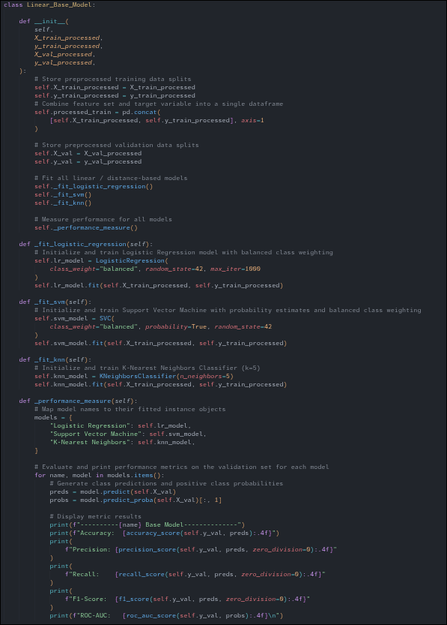
Note. Implementation of linear model objects. Linear models consist of Logistic Regression, Support Vector Machine (SVM), and K-Nearest Neighbors (KNN), and are trained and validated only on the train and validation sets.

Figure 21
Tree-Based Base Model Implementation
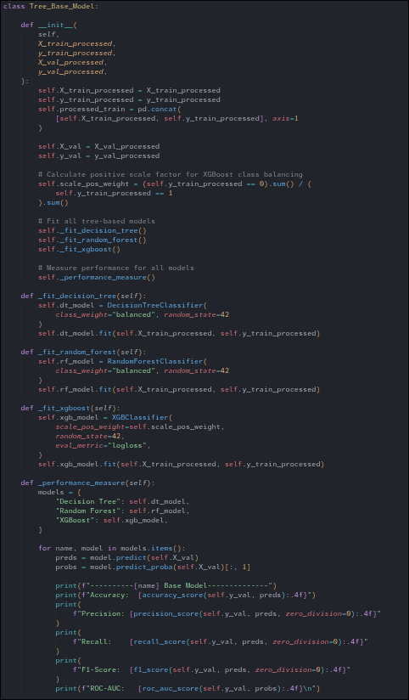
Note. Implementation of tree-based model objects. Tree-based models consist of Decision Tree, Random Forest, and XGBoost, and are trained and validated only on the train and validation sets.

Linear Models
Evaluation of the linear and distance-based baseline models reveals a strong trade-off between overall accuracy and sensitivity with respect to the positive class (Figure 22). Logistic Regression obtained the highest recall rate for the positive class, with a recall of 0.7838 and an ROC-AUC of 0.8449, even though its overall accuracy was lower at 0.7154 because of a high number of false positives. On the other hand, both the Support Vector Machine and the K-Nearest Neighbors achieved higher overall accuracies (0.7872 and 0.8081, respectively) but saw a considerable decrease in positive-class sensitivity, resulting in recalls of 0.4324 and 0.4054 together with lower ROC-AUC values (0.7452 and 0.6443). In all three of the linear algorithms, the low precision values (ranging from 0.1013 to 0.1213) indicate the substantial class imbalance that existed in the dataset before resampling.

Figure 22
Linear Base Model Performance Summary
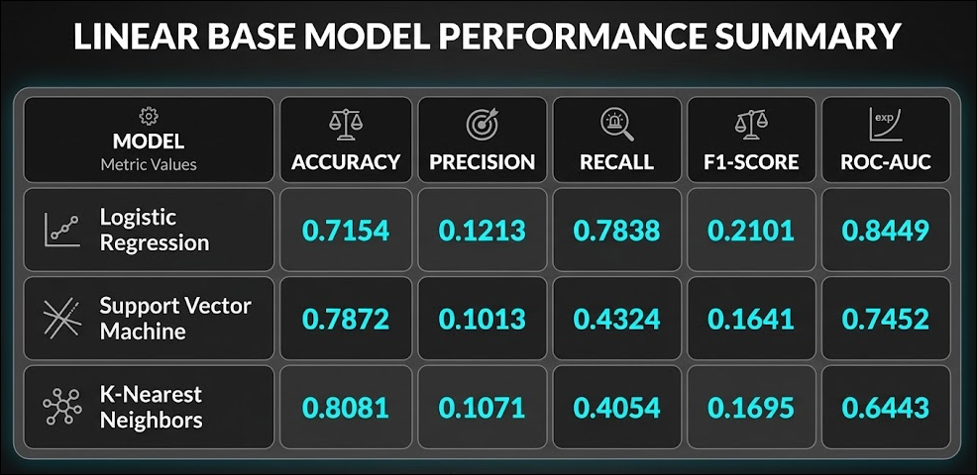
Note. Of the three linear models, Logistic Regression performed the best overall, achieving the highest Recall (0.7838) and ROC-AUC (0.8449) on the validation set.

Tree Models
Evaluation of the baseline tree-based models reveals that although the overall accuracy is high due to a large number of predictions being made for the majority class, the sensitivity with respect to the minority positive class is very poor (Figure 23). The Decision Tree, Random Forest, and XGBoost all achieved high Accuracy figures (0.8799, 0.9230, and 0.9321, respectively), but had extremely low Recall values (0.2703, 0.1351, and 0.1351). However, both Random Forest and XGBoost showed good ability to separate the classes and had respectable ROC-AUC scores of 0.7745 and 0.7808, while the Decision Tree performed much worse with an ROC-AUC of 0.5906.As in the case of the linear methods, the low Precision values (ranging from 0.1333 to 0.2000) highlight the difficulty of predicting on a highly imbalanced validation set; because the models were trained on oversampled data, they naturally generate more false positives, which suppresses overall precision.

Figure 23
Tree Base Model Performance Summary
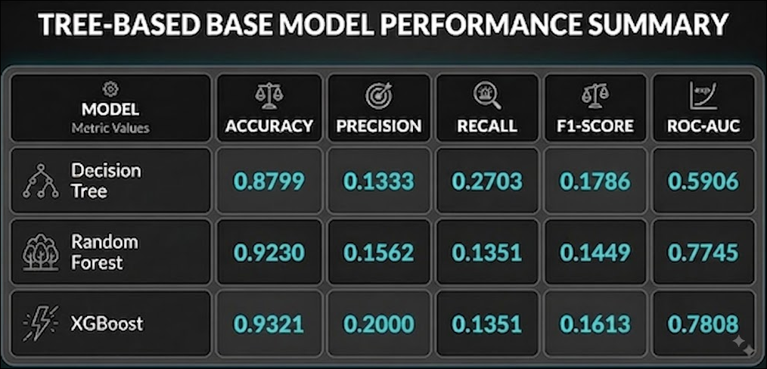
Note. Of the three tree-based models, XGBoost performed the best overall, achieving both the highest overall ROC-AUC (0.7808) and the highest Precision (0.2000) on the validation set.

Base Model Selection
The three models—Logistic Regression, Random Forest, and XGBoost—were picked to move on to the hyperparameter tuning stage, the main performance criteria that led to this choice being ROC-AUC and Recall since these measures best show a model's ability to separate the classes and to correctly identify the positive stroke cases in the highly imbalanced dataset. Logistic Regression was selected because it achieved the highest baseline Recall (0.7838) and had the best overall ROC-AUC (0.8449). XGBoost and Random Forest were chosen as the two best tree algorithms because of their good discrimination abilities (with ROC-AUC values of 0.7808 and 0.7745, respectively) and their high potential to improve sensitivity for the minority class when hyperparameter grids and the optimal decision thresholds are used.

Tuning
The main aim of this tuning stage is to ensure that the models are as capable as possible of correctly identifying cases involving the minority class without giving up precision altogether. In order to strike this balance, a solid two-step method of optimization was put into place.

The first step is Hyperparameter tuning (Figure 24), which involves adjusting each ML algorithm so that the models produce the most accurate probability rankings. The second step, Decision Threshold Tuning (Figure 25), then turns its attention to the final predictive outcome by optimizing the exact probability level at which a stroke is classified. By forgoing the default cutoff of 50%, the two-part approach means that the models become highly sensitive to the positive class while at the same time keeping a reliable decision boundary.

Figure 24
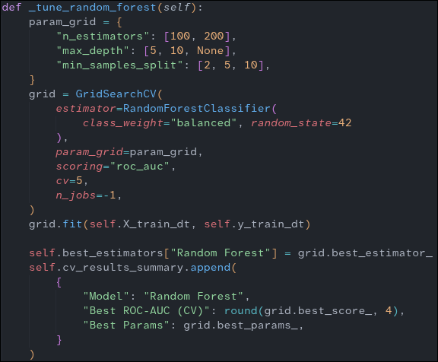
Hyperparameter Tuning Algorithm
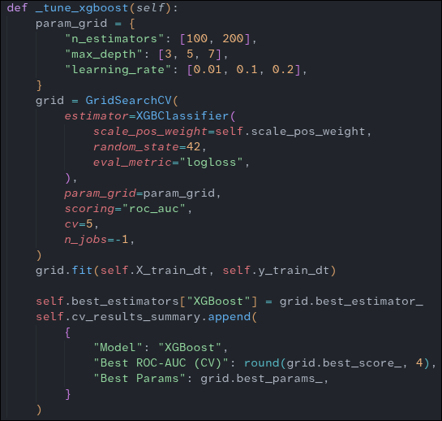
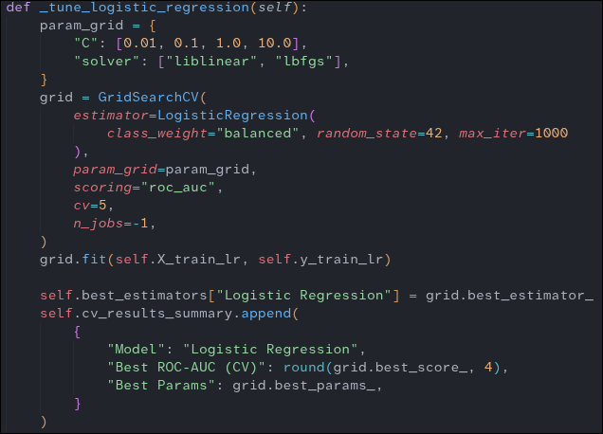

Note. Tuning the Logistic Regression model by optimizing the inverse regularization strength (C) and the optimization algorithm (solver).Tuning the Random Forest model by optimizing the number of trees in the forest (n_estimators), the maximum depth of the trees (max_depth), and the minimum number of samples required to split an internal node (min_samples_split). Tuning the XGBoost model by optimizing the number of gradient boosted trees (n_estimators), the maximum tree depth (max_depth), and the step size shrinkage/learning rate (learning_rate).

Figure 25
Threshold Tuning Algorithm
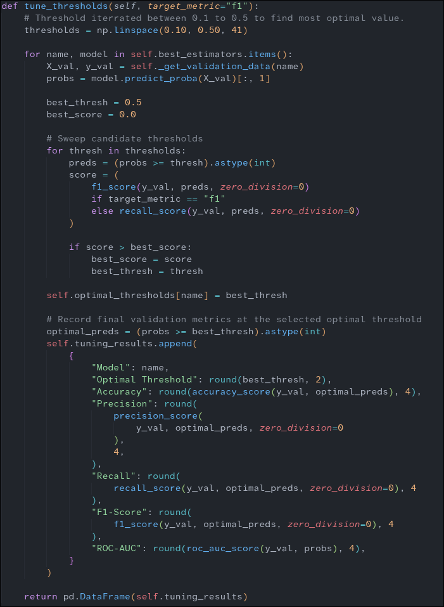
Note. Threshold tuning algorithm, which sweeps candidate decision boundaries between 0.10 and 0.50 to identify the optimal threshold that maximizes the F1-Score on the validation set.

Hyperparameter Tuning
For tuning, a grid search method, together with 5-fold cross-validation, is used on the SMOTE-balanced training sets in order to find the best parameters for Logistic Regression, Random Forest, and XGBoost; the search was deliberately optimized using ROC-AUC as the criterion. Since the models were assessed using ROC-AUC instead of ordinary accuracy, the grid search focused on hyperparameter combinations that effectively separate the classes and consistently rank the positive stroke probabilities higher than the negative ones. Results of the tuning are shown in Figure 26.

Figure 26
Hyperparameter Tuning Results
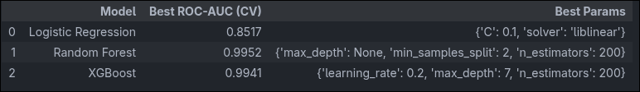
Note. Summary of the highest ROC-AUC scores achieved during 5-fold cross-validation and the corresponding optimal hyperparameters selected for each model.

Threshold Tuning
For threshold tuning, a probability sweep is carried out on the validation datasets in order to establish the best decision boundaries for the Logistic Regression, Random Forest, and XGBoost models which have been fine-tuned. The sweep is optimised specifically with reference to the F1-Score. Since the models are assessed using the F1-Score rather than the standard 50% cutoff, the tuning process involves choosing threshold values that balance precision and recall, thus ensuring a high level of sensitivity to cases of stroke without producing an excessive number of false positives. The outcomes of the threshold tuning are shown in Figure 27.

Figure 27
Threshold Tuning Results
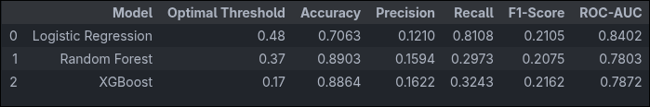
Note. Summary of performance metrics evaluated on the validation set using the optimal decision thresholds selected for each tuned model.

Model Results and Final Model Selection
Now that the tuning is complete, it is time to select the final, top-performing model to evaluate on the test partition. As stated before, the main objective is to achieve a model with the least amount of false negatives. Even if another model achieves slightly more balanced overall results, in the context of identifying potential stroke victims, the model that has a higher success rate in identifying these actual strokes must be chosen.
To help with the selection of the model, confusion matrices were visualized for each algorithm. Based on the results, the best performing model—again, the one that has the least false negatives—is Logistic Regression, which successfully identified 30 actual stroke cases and resulted in only 7 false negatives. In contrast, both Random Forest and XGBoost performed poorly in this critical metric. While they achieved fewer false positives overall, they missed the vast majority of the stroke victims, producing 26 and 25 false negatives, respectively (Figure 28). Because Random Forest and XGBoost failed to reliably detect the positive minority class, they were not selected for the final evaluation.

Figure 28
Final 3 Models Confusion Matrices
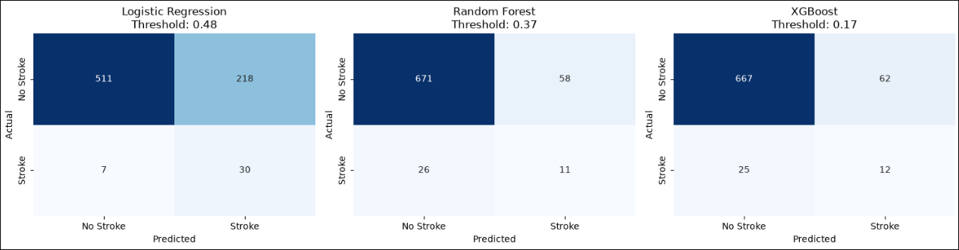
Note. Confusion matrices displaying the performance of the tuned Logistic Regression, Random Forest, and XGBoost models on the validation set at their optimized decision thresholds.

Final Test
For the final evaluation, the champion Logistic Regression model was tested on the entirely unseen test subset. It was put into use with the optimized decision threshold of 0.48, a value that had been deliberately chosen during the tuning stage in order to maximize the detection of the minority class. The model showed excellent consistency with its previous validation results, attaining a solid overall ROC-AUC of 0.8336. This proves that the model generalized well to new data and kept its ability to effectively distinguish between the stroke and non-stroke classes.

The confusion matrix shows the real-world effect of using this adjusted threshold. The model has managed to place a strong emphasis on sensitivity, since it correctly identified 31 of the 38 actual stroke patients and had only 7 false negatives. This gives a remarkable Recall figure of 0.8158. The natural consequence of attaining such sensitivity is a corresponding decrease in Precision (0.1144) and in overall Accuracy (0.678), due to the 240 false positives produced. Yet in the case of a medical screening procedure, this result fully matches the main aim—that is, to reduce the number of critical cases that are missed—because it is much better to investigate a healthy patient too extensively than to send a stroke patient home without having detected it.

The diagnostic curves given also confirm the manner in which the model performs on the imbalanced test set. The ROC curve shows a strong Area Under the Curve (AUC) of 0.83, which indicates good performance and is well above the level that would be expected from a random classifier. Moreover, the Precision-Recall curve gives an Average Precision (AP) of 0.19; although this value on its own seems low, it is typical in the case of highly skewed clinical datasets and is the result of a deliberate mathematical compromise aimed at raising the recall above 80%. In the end, the Logistic Regression model was found to be very effective for its intended real-world application. Results shown in Figure 29.

Figure 29
Final Champion Model Evaluation
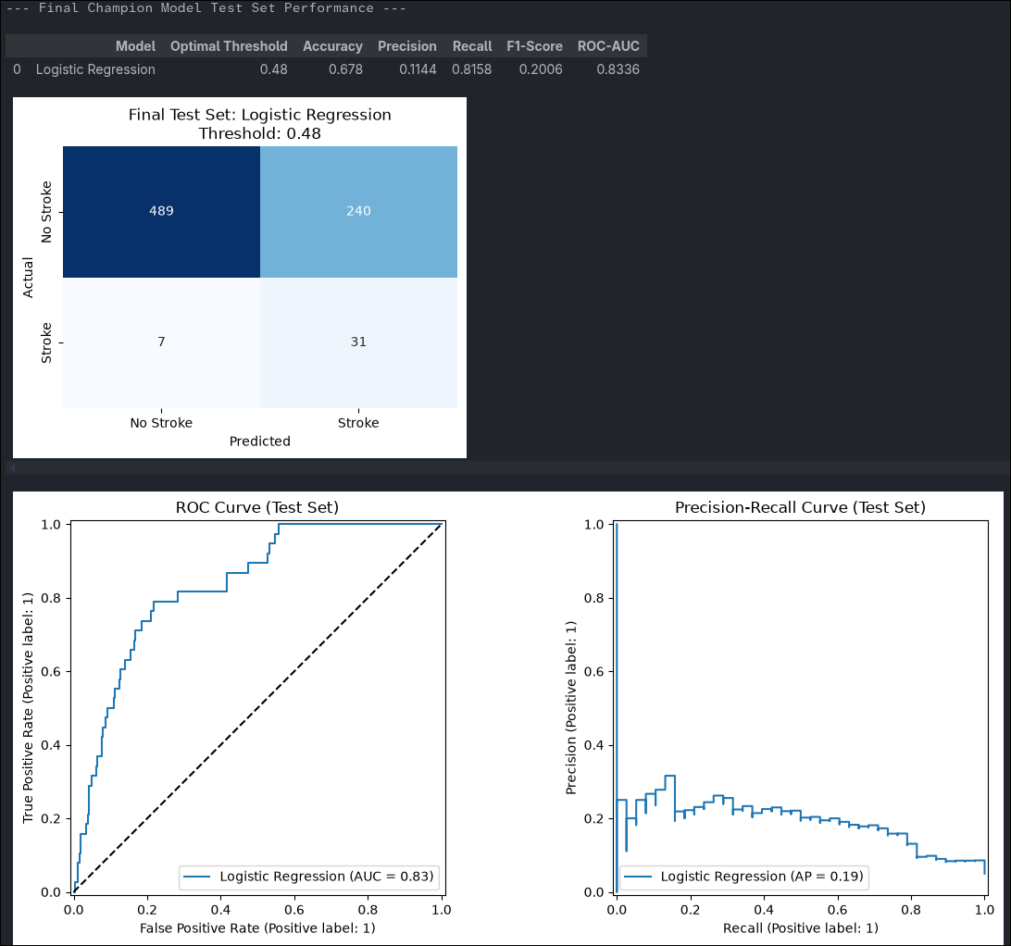
Note. Final test set performance metrics, confusion matrix, and diagnostic curves for the champion Logistic Regression model evaluated at its optimized 0.48 decision threshold.

Deployment Impact and Implications
Using this Logistic Regression model in a healthcare environment would be most effective as an automated, first-line screening tool rather than as a final diagnostic tool. If the model is incorporated, hospitals would be able to quickly identify patients who have a high risk of stroke according to their baseline information. Since the model has been specifically designed for high sensitivity, it serves as an important safety measure, making sure that faint or early signs of a stroke are not missed during busy clinical shifts. Doctors could then be confident about giving these identified patients the highest priority for immediate neurological evaluation, advanced imaging, or preventive care.

The most important practical consequence of using this model is the need to deliberately balance patient safety against the use of clinical resources. Because the model has a high recall rate, the vast majority of genuine stroke patients will receive timely and possibly life-saving treatments, which in turn greatly reduces both severe disability and death. On the other hand, the low precision means that the hospital will have to be ready to use its resources to investigate a large number of false positives. Although this may place an extra burden on medical staff and diagnostic facilities, many potential victims could be saved. In the end, the model offers a highly conservative and risk-averse approach that is in full agreement with the medical aim of protecting human life.

References
Chawla, N. V., Bowyer, K. W., Hall, L. O., & Kegelmeyer, W. P. (2002). SMOTE: Synthetic Minority Over-sampling Technique. Journal of Artificial Intelligence Research, 16, 321–357. https://doi.org/10.1613/jair.953

Chun, M., Clarke, R., Cairns, B. J., Clifton, D., Bennett, D., Chen, Y., Guo, Y., Pei, P., Lv, J., Yu, C., Yang, L., Li, L., Chen, Z., & Zhu, T. (2021). Stroke risk prediction using machine learning: a prospective cohort study of 0.5 million Chinese adults. Journal of the American Medical Informatics Association, 28(8), 1719–1727. https://doi.org/10.1093/jamia/ocab068

Feigin, V. L., Brainin, M., Norrving, B., Martins, S. O., Pandian, J., Lindsay, P., F Grupper, M., & Rautalin, I. (2025). World Stroke Organization: Global Stroke Fact Sheet 2025. International Journal of Stroke, 20, 132–144. https://doi.org/10.1177/17474930241308142

Declaration of AI Use
This report was prepared with the assistance of artificial intelligence (AI) tools. Specifically, generative AI was utilized to create certain images included in the document. Additionally, AI was employed to assist with writing corrections, grammatical editing, and overall language improvement.

